Create a new project. Import all your video.
This will automatically create a sequence 1.
DO NOT USE Sequence 1!

Take one of your video clips, drag and drop it on the new sequence button.
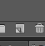 this is the icon that means new sequence

This will create a new sequence with the same name as your clip.
Click on the video footage in the new sequence and delete it.

Go to your project window and rename the sequence to the name of your movie.

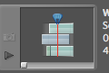 this is the icon that means sequence

This is your project panel
