Here are the folders you are looking for:
When you find the AVCHD icon with the Quicktime Q double click on it.

Then you'll see them grouped together, like this: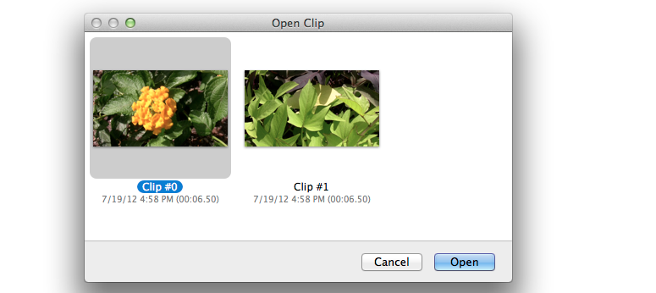

Simply select the clip you are interested in, then click Open to open in a player window.

The clip will open in quick time then choose EXPORT from the FILE menu, 1080 p and save to your computer NOT the server.

