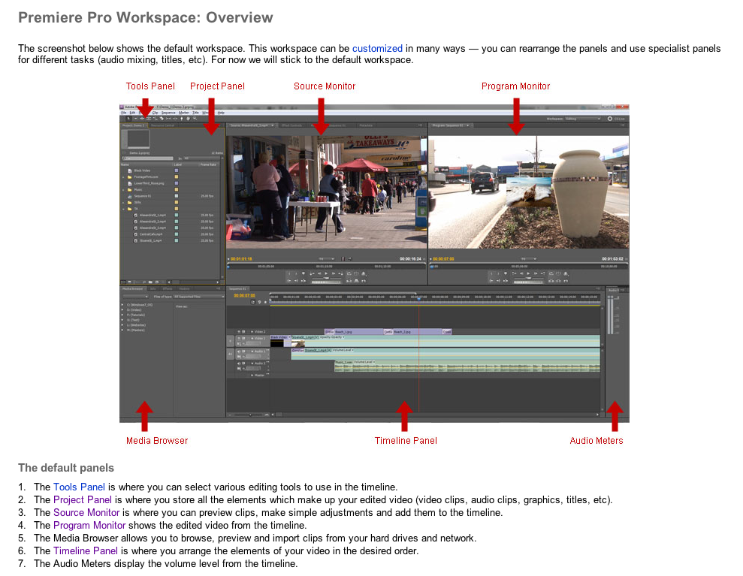

BASIC CUTS-ONLY EDITING
1. In the PROJECT WINDOW, double click on the icon of a VIDEO file. The clip appears in the SOURCE WINDOW.
2. View the clip using the playback buttons or scrubbing the play head.
3. Place the play head at the IN point and click the MARK IN (I) button.
4. Place the play head at the OUT point and click the MARK OUT (O) button.
5. Conversely, you can drag the IN and OUT handles to determine the In & Out points.
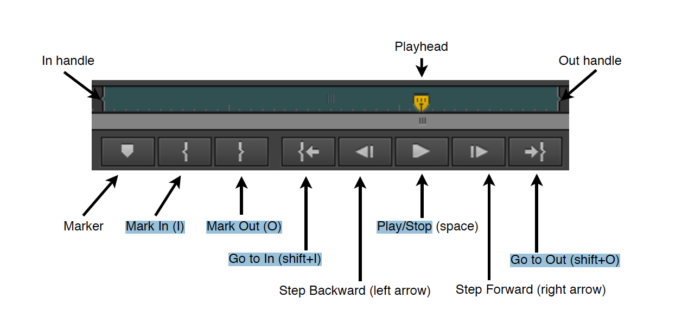
6. The duration of the IN/OUT DURATION can be seen in the white time code indicator in the lower right-side of the SOURCE WINDOW

7. Click the frame in the SOURCE window and drag to the TIMELINE.
8. Repeat Step 1 - 6 as needed.
9. Make sure you are using the SELECTION tool and SNAP is enabled.
10.To place a clip between two other clips, hold down COMMAND and click & drag the clip to the desired location. A number of RIGHT arrows appear on the cursor indicating the clips will be pushed to the right. Release the mouse button.
11.Adjust the ZOOM SCROLL to view the clips in the timeline.
12.Click TOGGLE TRACK OUTPUT to mute audio in the clips on that audio track.
13.Note: You can also adjust the clip length in the TIMELINE by dragging the ends of the clip.
14.Note: You can create multiple SEQUENCES to experiment and make different edits using the same clips. In the PROJECT window, click the NEW ITEM icon and select SEQUENCE from the pop-up menu. The new SEQUENCE appears in the PROJECT window. Rename as necessary.
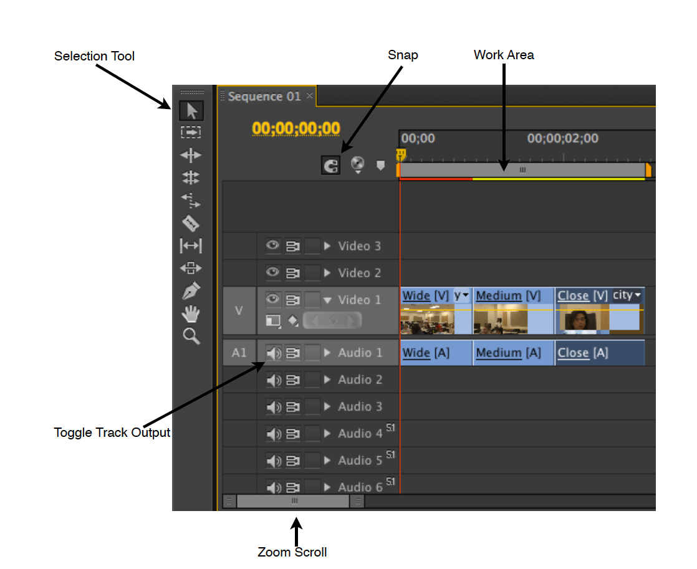

TRANSITIONS
1. In the PROJECTS window, click the EFFECTS tab.
2. Drill down into the VIDEO TRANSITIONS folder.
3. Select a transition and drag the icon to the TIMELINE between two clips.
4. Double click the TRANSITION in the time to edit the transition parameters in the
SOURCE WINDOW.
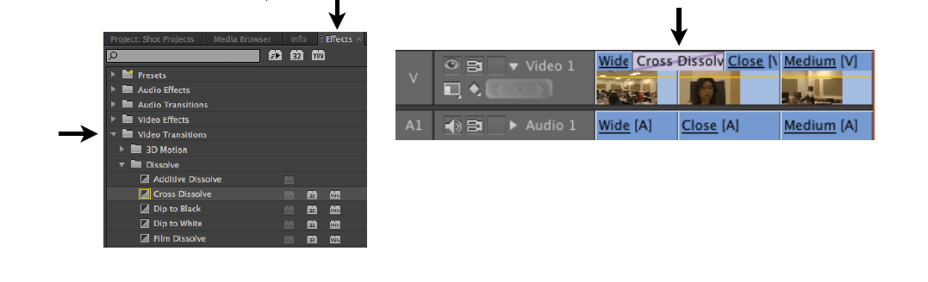

STILL TITLES
1. Pull down TITLES to NEW TITLE to DEFAULT STILL. Make sure the settings match the screen shot below. Name the Title and click OK.
2. In the TITLE EDIT window, click the TYPE TOOL and click in the center of the title screen. The cursor blinks. Select a TITLE STYLES. Type the title.
3. Click the SELECTION TOOL and click the two CENTER buttons to center the title.
4. Close the window when done. Your changes will be saved.
5. The TITLE appears in the PROJECT WINDOW. Drag the title to the TIMELINE.
6. Adjust the duration by dragging the end of the title clip or right-click (CTRL+click) and select SPEED/DURATION and enter the desired duration.
7. Hold down the Command key to insert the title between two clips
